Introduction to Database

-Term project-

2016310936 우승민

Contents

1. Schema Diagram 4

1.1 Overall E-R diagram 4

1.2 Entities 4

1.3 Relational Schema 6

2. DDL statements 7

2.1 userdata 7

2.2 item 7

2.3 watch 8

2.4 watch 8

2.5 Event 8

2.6 Trigger 9

3. DML statements 10

3.1 Sign up 10

3.2 Login 10

3.3 Sell 11

3.4 Status 11

3.5 Search 12

3.6 Check bid 14

3.7 Check Account 15

4. Administrator mode 16

4.1 Login Administrator 16

4.2 Manage item 17

4.4 Show profit 18

19

5. User manual 20

5.1 Login / Sign up 20

5.2. Sell 21

5.3 Status 21

5.4. Search 22

5.5 Check bid 25

5.6 Check Account 25

# Schema Diagram

## 1.1 Overall E-R diagram

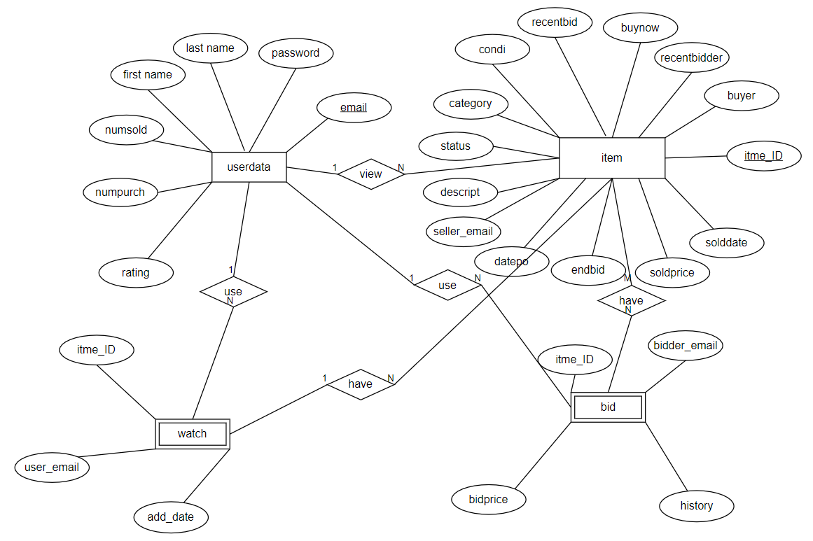

## 1.2 Entities

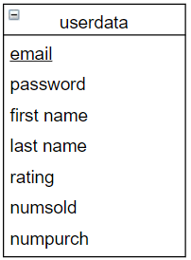1) userdata

Userdata has user’s information. When users sign up, then email, password, first name, last name are made. And email is a primary key. Rating, numsold, numpurch are changed when user buys item or sells item.

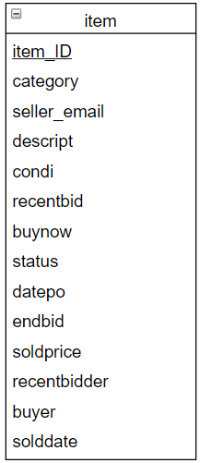2) item

Item has information of item like it’s category, condition, and so on. Item_ID is a primary key of item. When user uploads item, then user should input it’s category, description, condition, buy-it-now price, end bidding date. So item_ID, category, seller_email, descript, condi, recentbid, buynow, status, datepo, endbid are written automatically when users upload item. And other things like status, buyer and so on are changed when item is sold, or some user bids it.

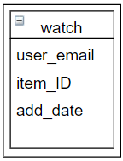3) watch

When user searches item by category, description and so on, user watches many items. And all of items which user watch, are uploaded automatically and also add_date which means the time user watches items is uploaded.

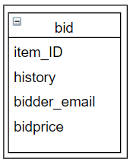4) bid

When user is bidding items, some information is uploaded. Bidder_email means user_email, item_ID means item which user is bidding, bidprice means the price which user sets money to bid item, history means the time when user bid.

## 1.3 Relational Schema

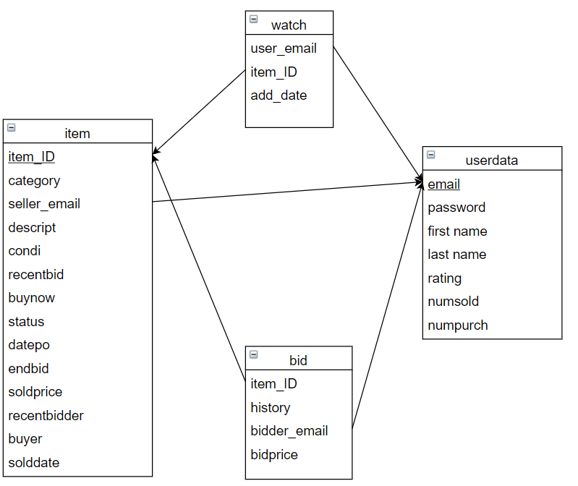

# 2. DDL statements

## 2.1 userdata

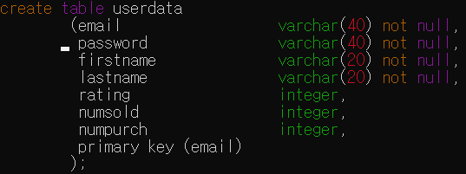

Email, password, firstname, lastname should be written so they can’t be NULL. And data type is varchar and others data type is integer. Email is primary key.

## 2.2 item

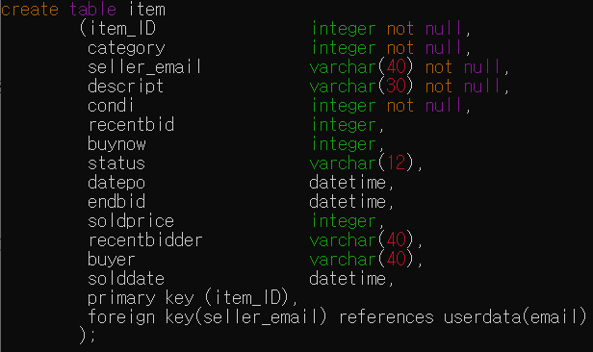

Datepo, endbid, solddate data type is datetime like “2020-12-03 12:00:00”. Category and condition data type is integer because I set like this. And item_ID is primary key. Seller_email is foreign key references by userdata.

## 2.3 watch

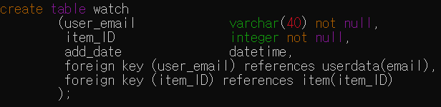

When user search items and watch list, then watch list is made. User_email, item_ID are foreign key, add_date means the time when user watch items.

## 2.4 watch

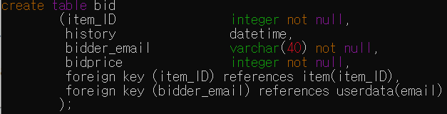

When user bid items, then bid information is inserted. History means the time when user bid items.

## 2.5 Event





These two events are activated every 1 second. When time is over item’s end bidding date, then item’s information is changed. If item is bidded at least one or more, then item is sold by highest bidder. Else item is not bidded by anyone, then item is failed bidding.

## 2.6 Trigger



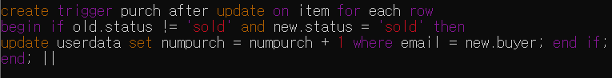

These two triggers are activated when some user buy items. Users who buy items gets +1 at num of purchasing item. And users who sell items gets +1 at num of sold, rating.

# 3. DML statements

## 3.1 Sign up

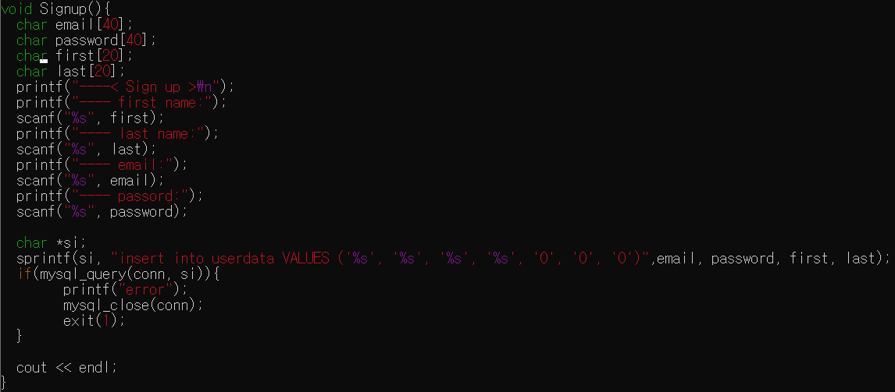

When user sign up, then new information is inserted at userdata. Email, password, first name, last name is written by user, and others are set 0.

## 3.2 Login

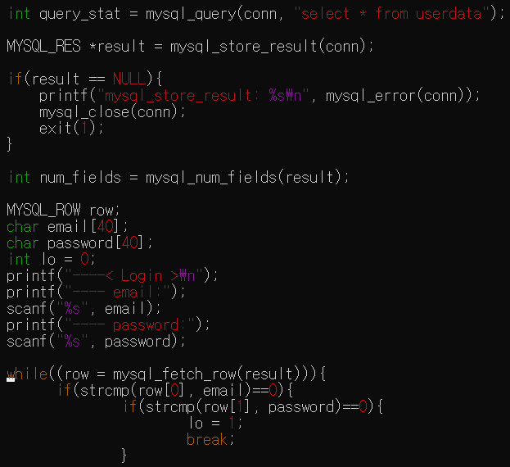

When users select login menu, they should enter email and password. After then, database checkes whether their email and password are existed and right.

## 3.3 Sell

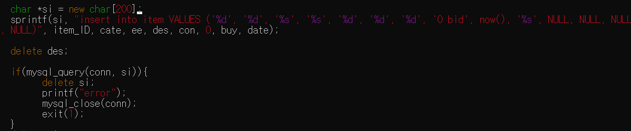

When users upload item, then new information is uploaded. Item_ID is set by the order in which item is uploaded. Cate means category, ee means user’s email, des means desciption, con means condition, buy means buy-it-now price, date means end bidding date. These data is set by users. So I use sprintf.

## 3.4 Status

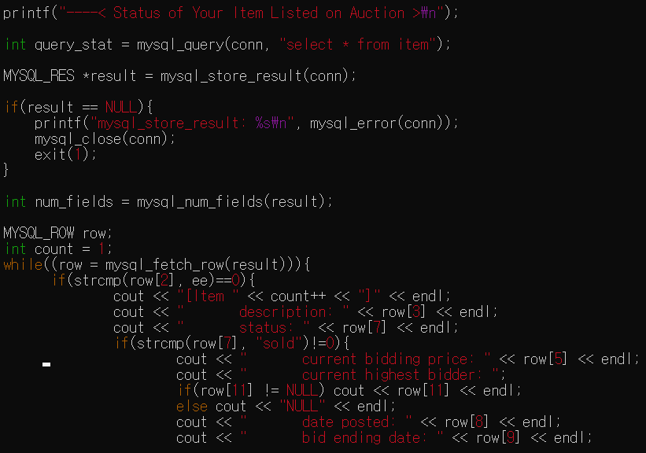

In status function, program bring information from item. And checking is there any items which users upload to sell. And if it is existed, then show list of them.

## 3.5 Search

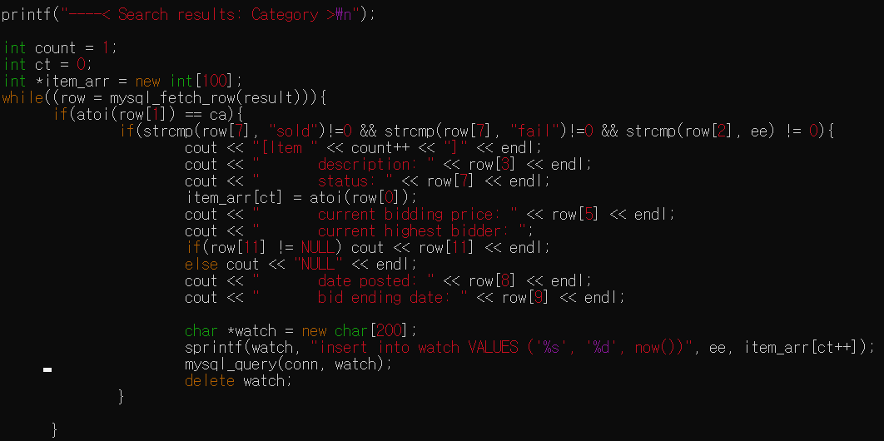

When users search items by category or description, .. . Then, they watch item list which item is not sold, not fail, and not uploaded by searching user. And these watching list is inserted at watch table.

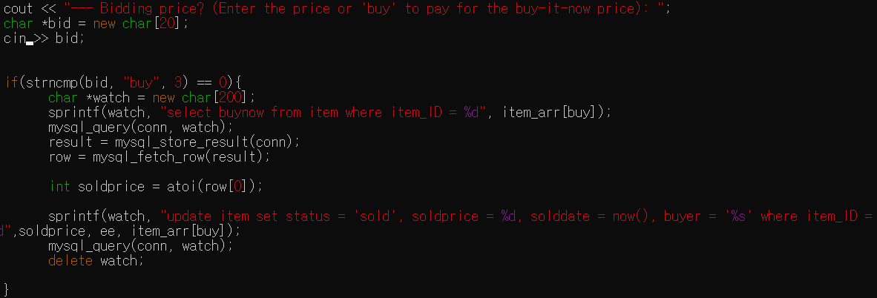

When user selects item which users want to buy or bid. Then they are asked Bidding price. When user enter ‘buy’ then item’s information is changed. Status -> sold, soldprice -> user input, solddate -> now time, buyer -> user_email.

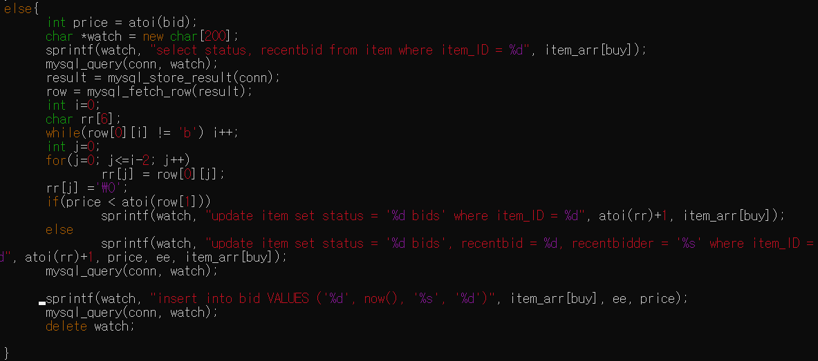

Else user enter number then item is not sold but bidded. So item’s information is changed not like sold. Status -> n bids. And if user sets highest bidding price, then recenbid, recentbidder is also changed.

And bid table also uploaded.

## 3.6 Check bid

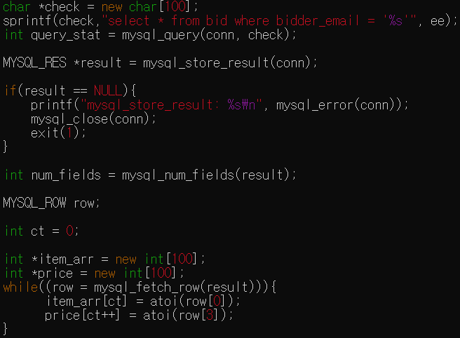

First, system check bid table so find all of items which are bidded by user.

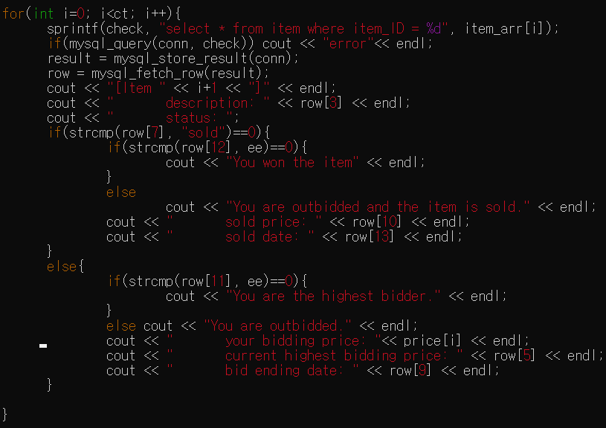

And then, show user about their bidding item.

## 3.7 Check Account

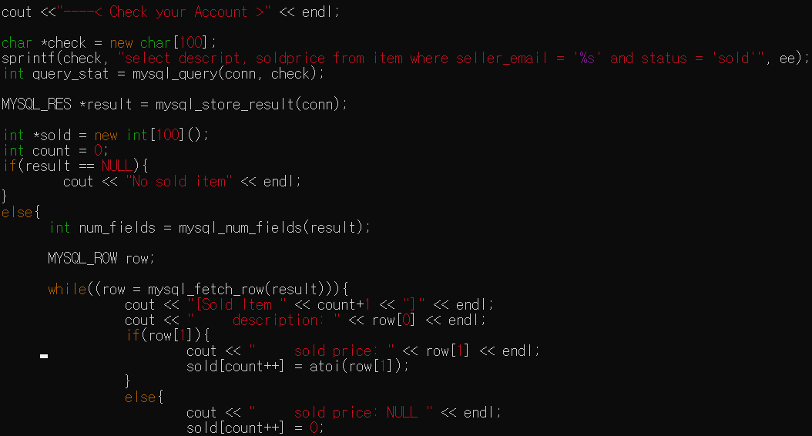

First, system show item list which users uploaded to sell. So finding items which user uploaded and check if they are sold.

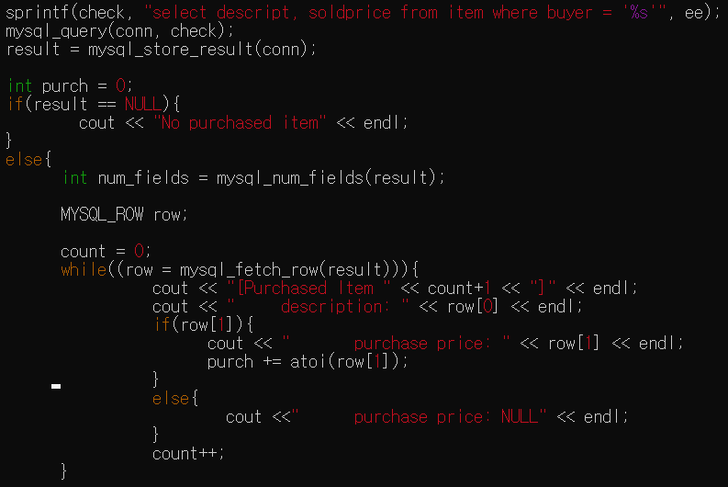

After, system show item list which users buy. So finding items which user buy.

# 4. Administrator mode

## 4.1 Login Administrator

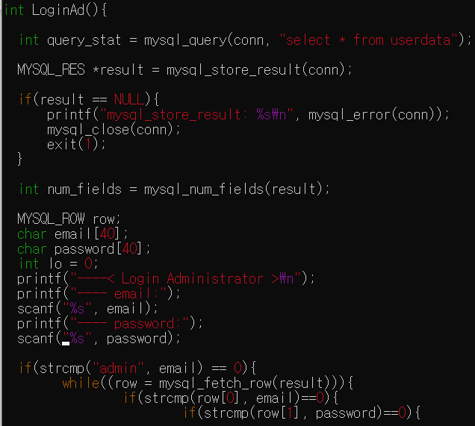

For using administrator mode, you should select login administrator. And unlike login, it does not need user’s email by reference because administrator email is always ‘admin’.

## 4.2 Manage item

Show item list is same as users searching item. By category, description, seller, date. So I skip this. After then admin can change item information.

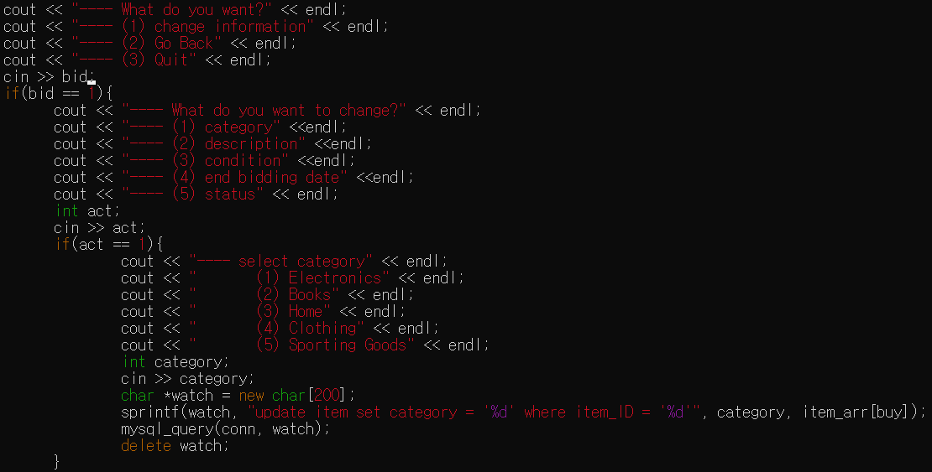

Admin can change item information. If admin thinks this item’s category is wrong, or end bidding date is too short or long, and so on. Changing other things is not allowed.

4.3 Manage user

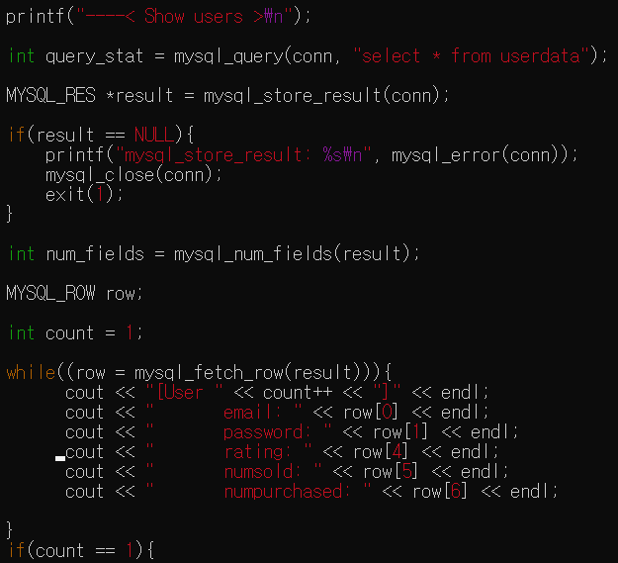

To manage user, first system show admin user list.

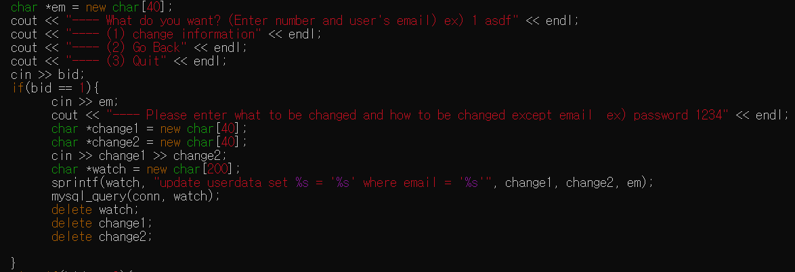

And then, admin selects user to change. And then, enter which information to change and to what.

## 

## 4.4 Show profit

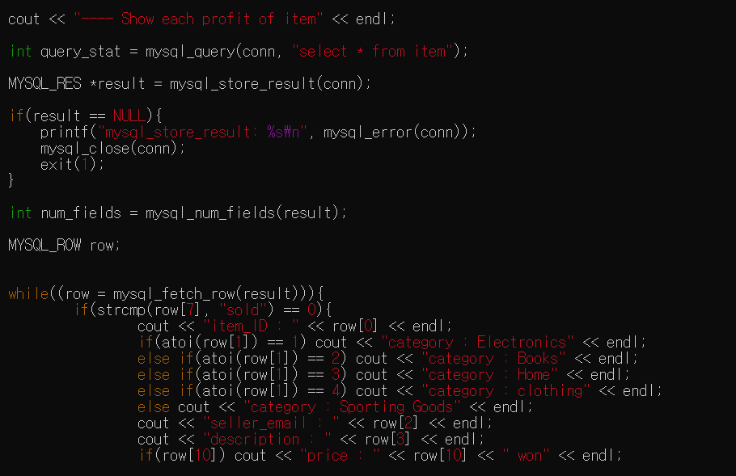

First, system show admin item information which is sold.

## 

And then distinguish them group by user. Because commission is different by num of sold.

# 5. User manual

## 5.1 Login / Sign up

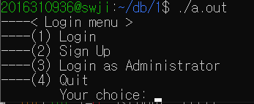

To login, enter ‘1’. To sign up, enter ‘2’.

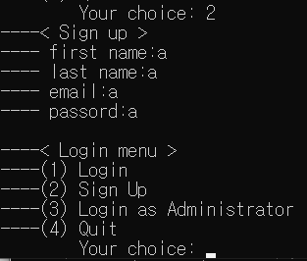

If you select 2, then you should enter 4 things in order. After then system go back login menu.

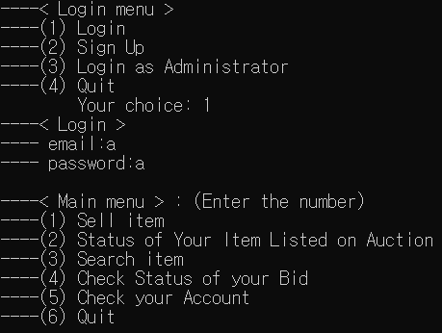

If you want to login, you should enter what you input at sign up. After then system go main menu.

## 5.2. Sell

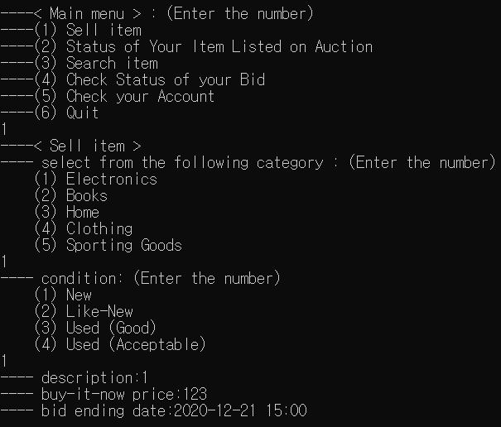

If you select sell menu, then you should enter some things in order. Category, condition, buy-it-now price should be only number. And bid ending date should be entered “YYYY-MM-DD HH:MM”

After uploading, system go back main menu.

## 5.3 Status

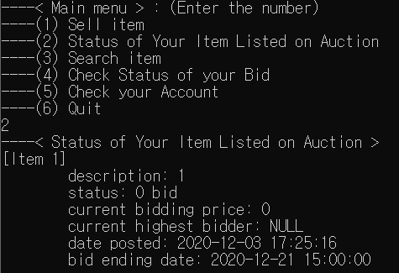

If you select status menu, you can watch your item list.

## 5.4. Search

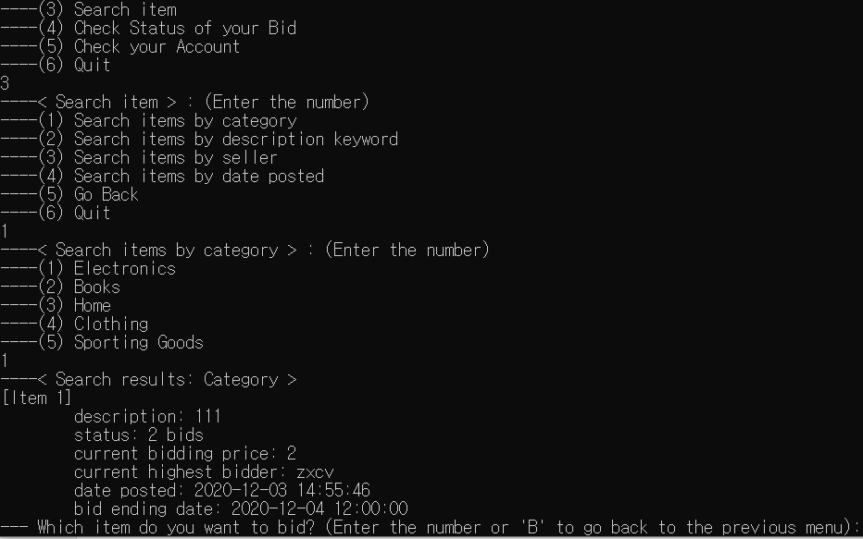

If you select search item, then you select searching way. In category, you just enter number.

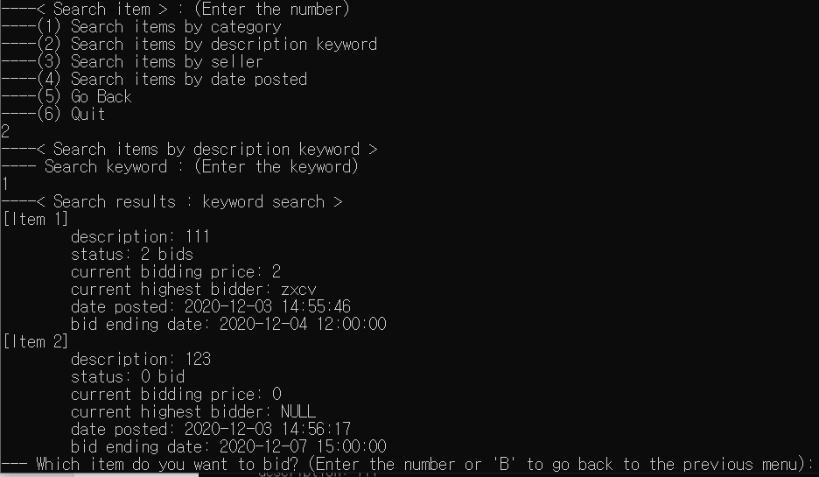

In description, system shows item list which description starts by string you enter.

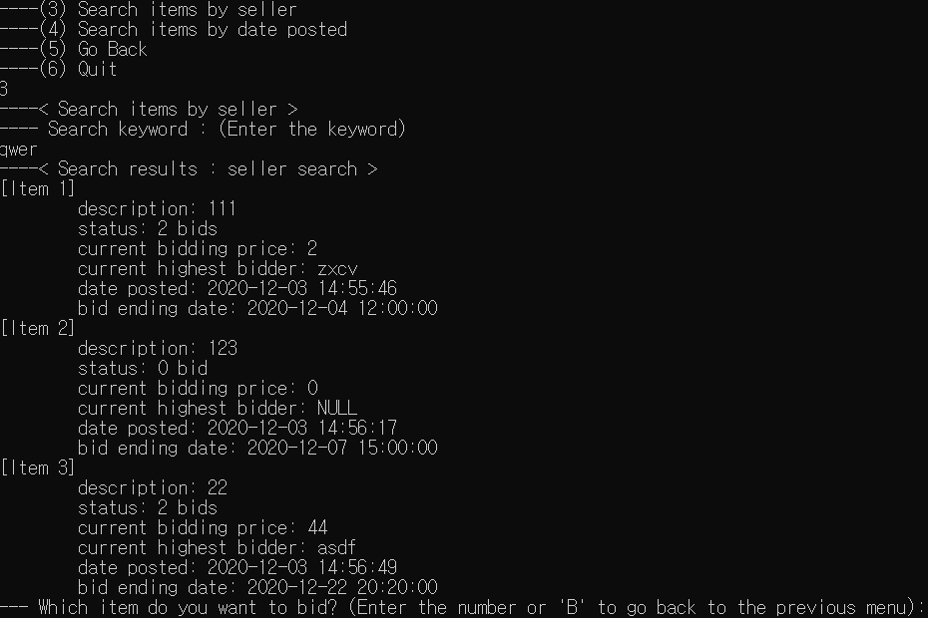

In seller, you should enter seller’s email exactly.

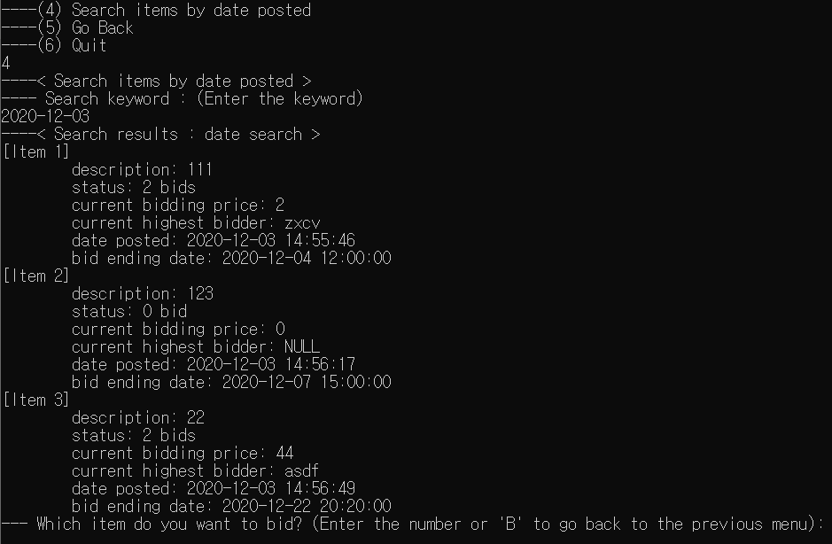

In date posted, you should enter like ‘YYYY-MM-DD’.

After then you enter item number or ‘B’ to go back previous menu.

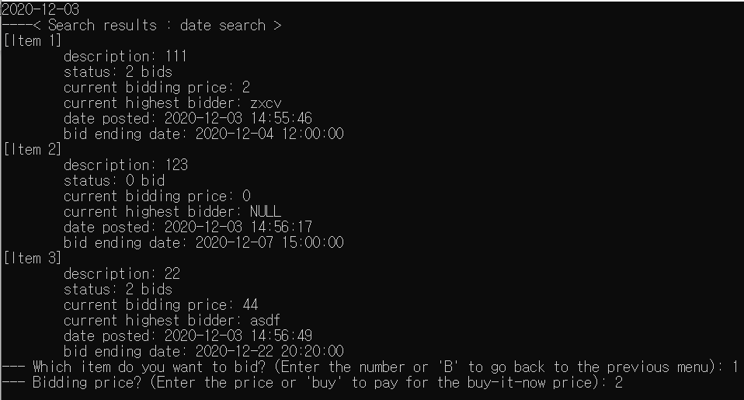

If you select item, then you select bidding or buying now. If you enter number, bidding is start. Like under image.

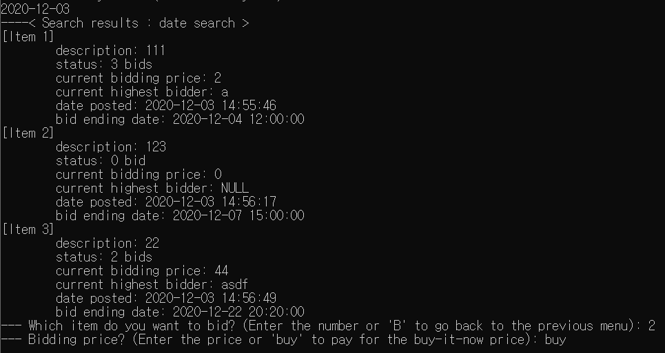

If you enter ‘buy’ then item is sold by you and list is changed.

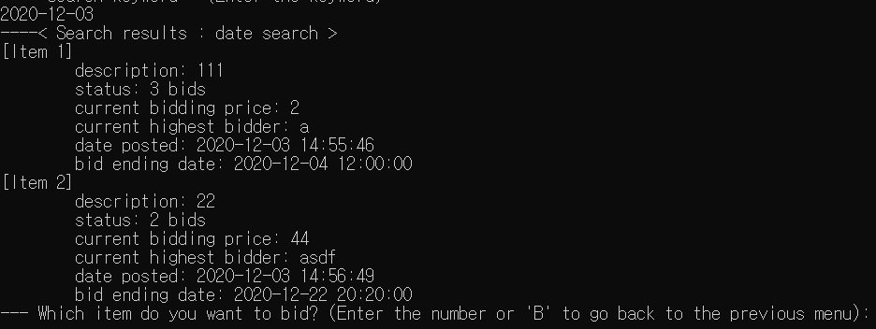

## 5.5 Check bid

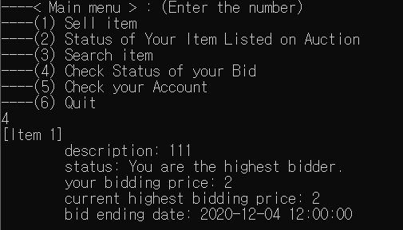

If you select check bid, then you can watch your bidding list.

## 5.6 Check Account

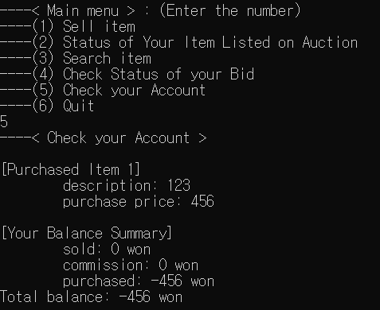

If you select check account, you can watch sold item list, and purchased item list. Also you can see your total money.